Agency Admin Guide
Log on screen
User Login –Select this tab to log on if you not an admin.
Agency/Admin Login– Select this tab to log on if you are an agency admin.

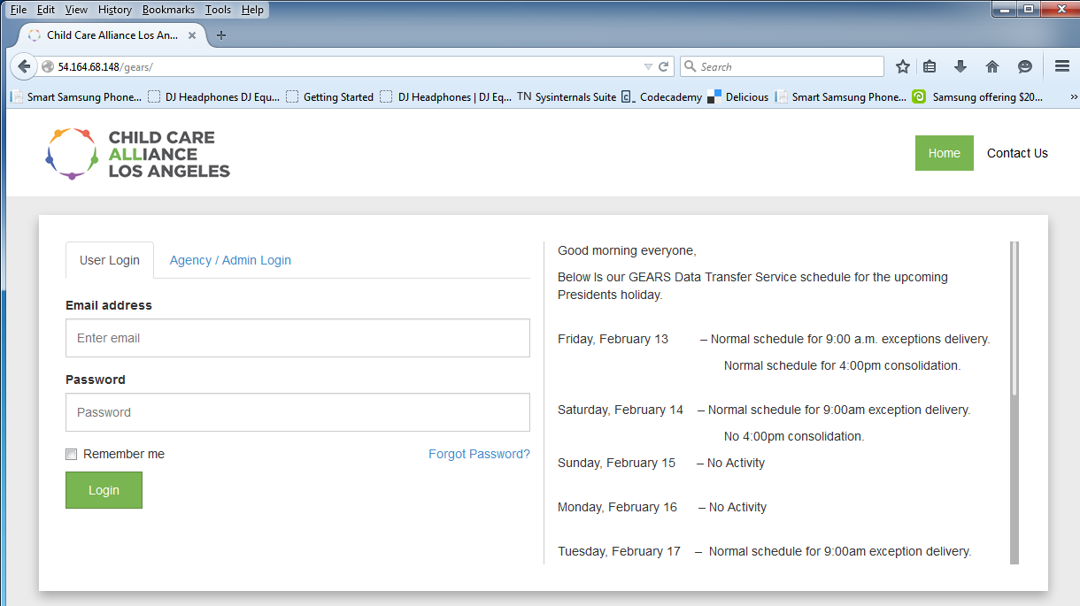
Forgot Password? – If you forgot your password, click on” Forgot Password” link and you will be prompted to enter your email address. A temporary password will be sent to your email.
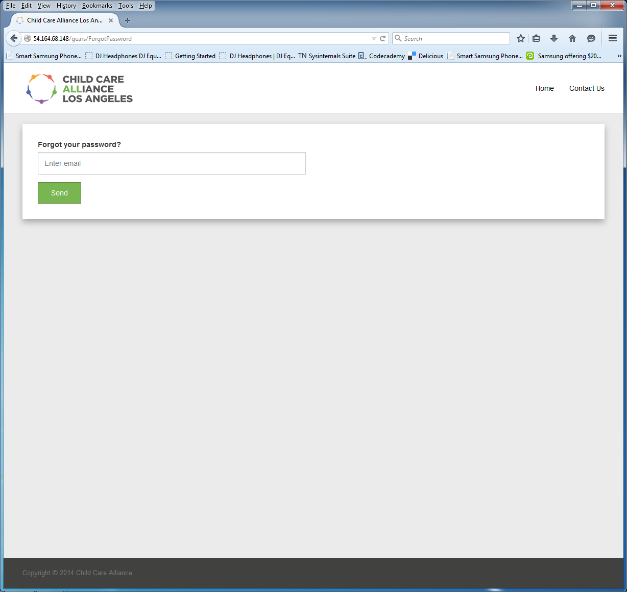

Messages
Once you successfully log on the Gears Data Transfer Application, the “Messages” screen is where you can view messages posted by the system administrator.
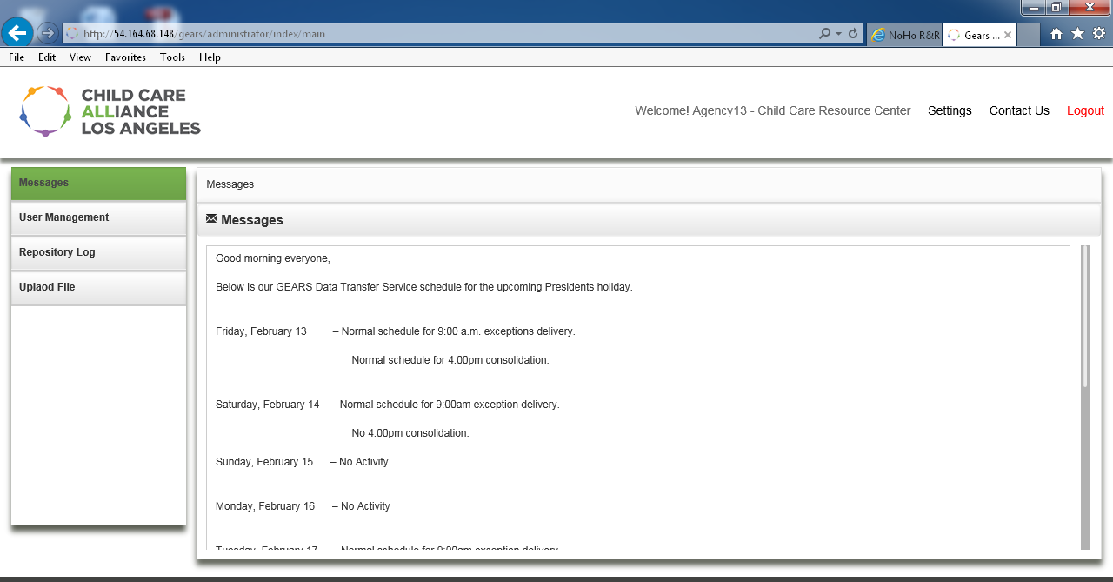
User Management
From the “User Management” tab you can select “Add User” and “Users List”. To add a new agency user click on the “Add User” tab and enter the applicable information. After you enter the Name, Email id, Address, Phone, and Password click on the“Save changes” button.

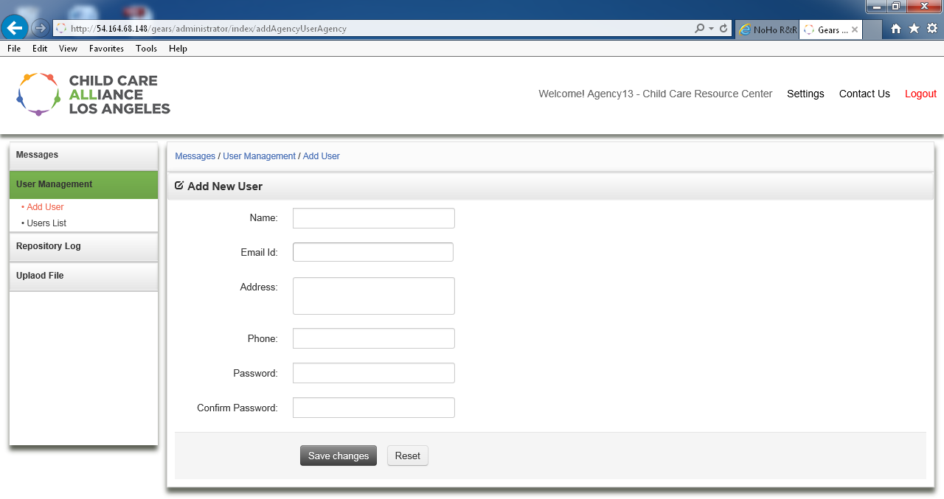
Users List
To list all agency users and to edit or delete an agency user, click on the “Users List” the following will be displayed:
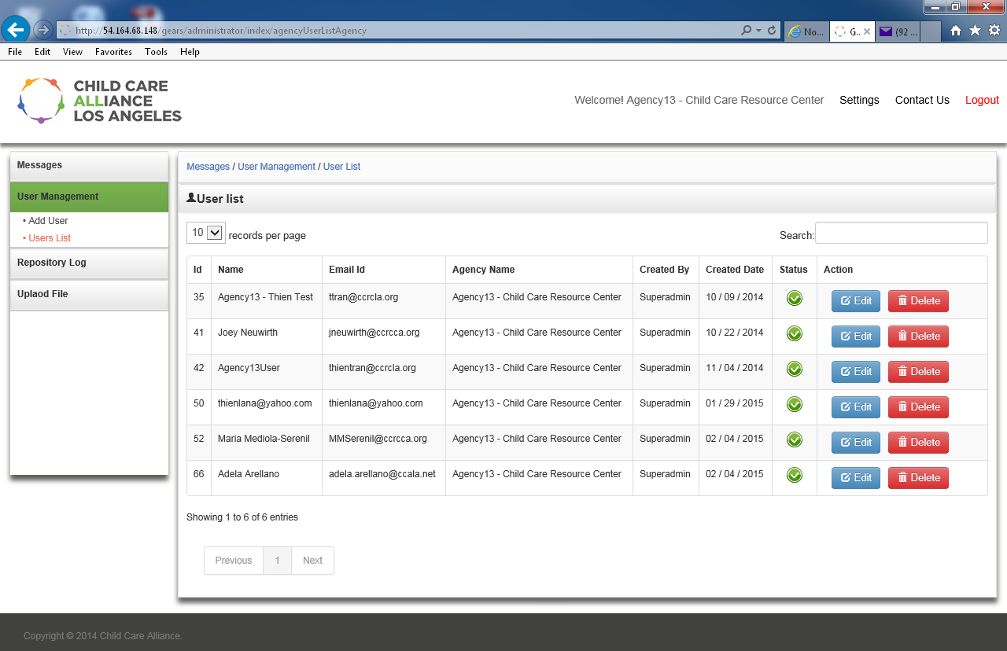

Deleting a user will delete all the ﬁles that will delete all the files that are associated with that user.

Settings tab - On the setting tab you can change your:
- Name
- Address
- Phone Number
- Password
- You cannot change your email address, because that’s your username

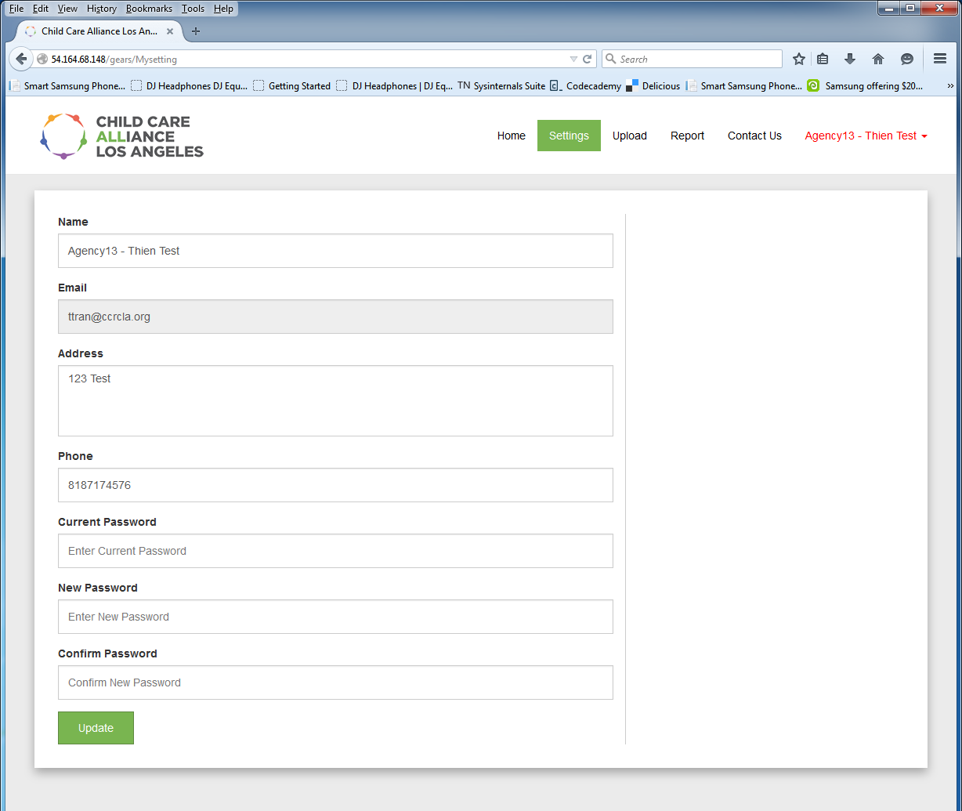
After you finish editing the information in the settings tab, click on Update to save the changes.

Repository Log section – The report tab gives you information about your data.
- File Name – Uploaded file name
- User Name – Who uploaded the file
- Agency Name – Which agency the user belongs to
- No. of Records – Number of records in the uploaded file
- Total Amount – Total amount on the file
- Upload – Time and date when the file was uploaded
- Consolidated – Time and date when the file was consolidated
- Exception – View and download exception
- Download – Serves as a repository and you can download your original files here
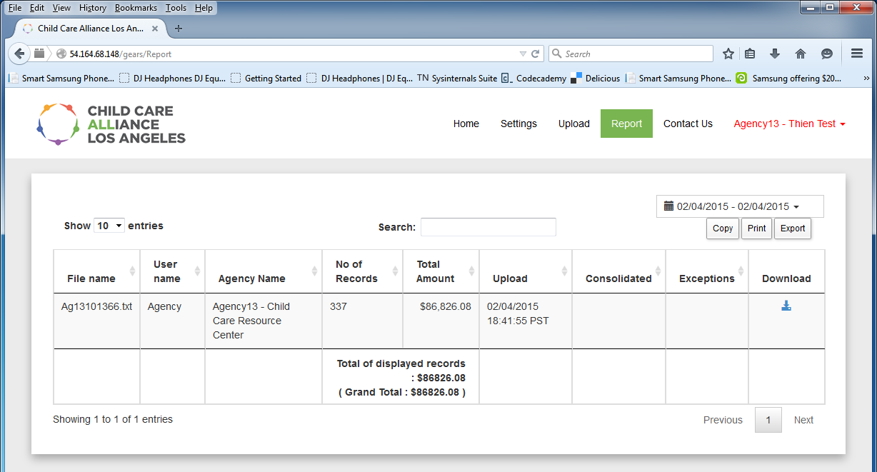
- Search for uploaded files in the Search box.
- You can view the display total and grand total based on you search criteria.
- Print
- Copy
- Export
  - CSV or PDF
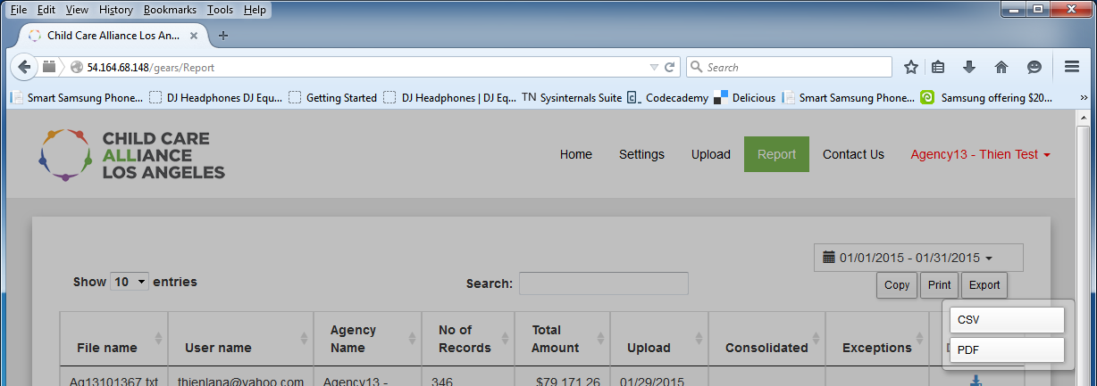

Upload Files – Upload files here.
- Upload multiple files
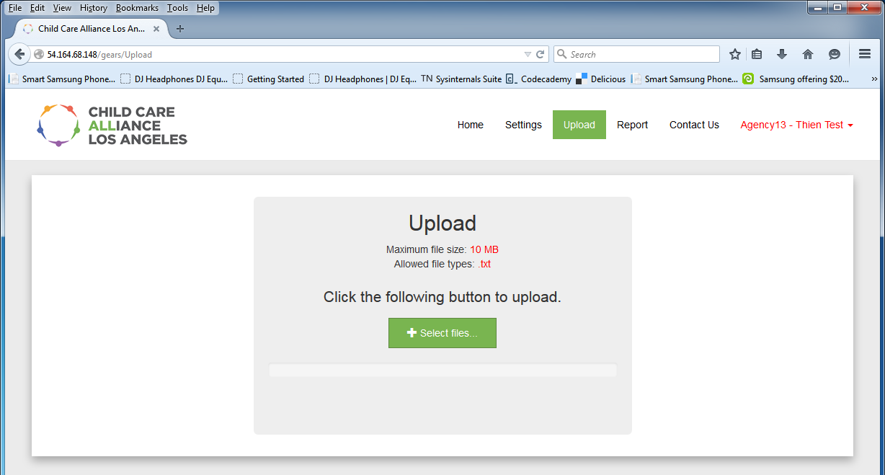
- Click on “View Exceptions” link and a new tab will open for you to review the exceptions before submitting. Select the delete icon if you want to delete the uploaded file.
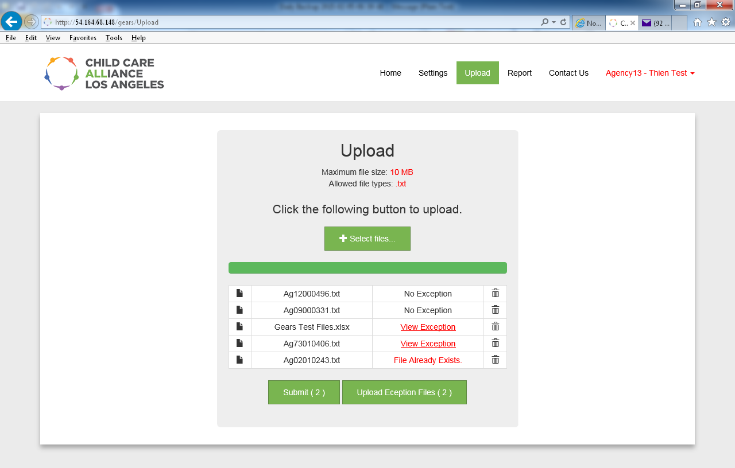
Contact Us – Contact information for support

